|  |  |
| --- | --- |
| **Ex.No:12** | **Simulate elliptical orbits in pygame** |
|  |

***Aim:***

To develop a python to simulate elliptical orbits in pygame.

***Algorithm:***

|  |  |
| --- | --- |
| **Step 1:** | Import and initialize pygame with pygame.init() |
| **Step 2:** | Create a graphical screen (Surface) with pygame.display.set_mode(600, 300). |
| **Step 3:** | Assign xRadius as 250 and yRadius as 100 |
| **Step 4:** | Assign degree as 0 |
| **Step 5:** | Compute as x1 as int(math.cos( degree * 2 * math.pi / 360) * xRadius) + 300  Compute as y1 as int(math.sin(degree * 2 * math.pi / 360) * yRadius) + 150 |
| **Step 6:** | Fill Screen with Black Color |
| **Step 8:** | Draw the Circle on screen in blue color at (300,150) with radius 35 |
| **Step 9** | Draw the Elipse on screen in white color at (50,50) and (500,200) in size. |
| **Step 10** | Draw the Circle on screen in blue color at (x,y) with radius 15 |
| **Step 11** | Increment degree by 10 value |
| **Step 12** | If degree is greater than 360 goto 4 else goto Step 5 |
| **Step 13** | The pygame.display.flip() method makes everything we have drawn on the screen |
| **Step 13** | If user want to quit goto Step 14 else continue |
| **Step 14** | Stop Process |

**Program:**

import pygame

import math

import sys

pygame.init()

screen = pygame.display.set_mode((600, 300))

clock = pygame.time.Clock()

while(True) :

for event in pygame.event.get() :

if event.type == pygame.QUIT:

sys.exit()

xRadius = 250

yRadius = 100

for degree in range(0,360,10) :

x1 = int(math.cos( degree * 2 * math.pi / 360) * xRadius) + 300

y1 = int(math.sin(degree * 2 * math.pi / 360) * yRadius) + 150

screen.fill((0, 0, 0))

pygame.draw.circle(screen, (255, 0, 0), [300, 150], 35)

pygame.draw.ellipse(screen, (255, 255, 255), [50, 50, 500, 200], 1)

pygame.draw.circle(screen, (0, 0, 255), [x1, y1], 15)

pygame.display.flip()

clock.tick(5)

**Output:**

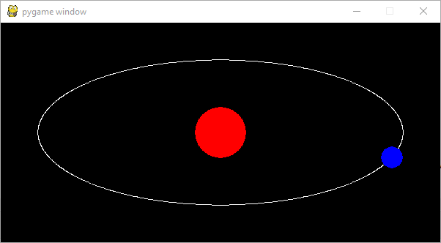

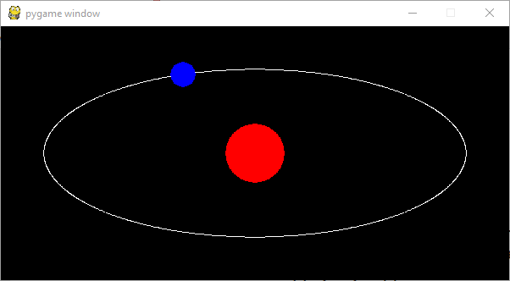

***Result:***

Thus the python program simulate elliptical orbits in pygame was developed and tested successfully.